BOARD OF DIRECTORS
MINUTES OF MEETING: April 22, 2025
1
The Board of Directors of Caddo Basin Special Utility District met in regular session
on Tuesday April 22, 2025, at the District Office located in Floyd, Texas at 6:30 p.m.
Present were:
Jerry Leinart, President
Elwood Jones, Secretary/Treasurer Kenneth Pendergrass, Director Ronnie Clack, Director
Kirk Hammack, Director
Kevin Wendland, General Manager Michelle Metcalf, Business Manager
Absent were:
Charlie Patterson, Vice President Bear Boyle, Director
The meeting was called to order at 6:28 p.m.
- Invocation was given by: Kirk Hammack
- Public Comment: N/A
- On a motion by Kenneth Pendergrass, seconded by Elwood Jones, the Board unanimously approved the minutes for the March 31, 2025 meeting.
- On a motion by Elwood Jones, seconded by Ronnie Clack, the Board unanimously

approved the Financials for March 2025.
2
- On a motion by Kenneth Pendergrass, seconded by Kirk Hammack, the Board unanimously approved the Quarterly Report and Pledge Report.
- On considering moving work orders to a digital platform, the subject was tabled until the staff visits Bear Creek SUD to see how they like the system.
- Operation Managers Report: Discussion of system repairs, maintenance, and/or customer service matters.
- Executive Session:
At any time during the meeting and in compliance with the Texas Open Meetings Act, Chapter 551, Texas Government Code, the Board of Directors may meet in executive session on any of the above agenda items or other lawful items for consultation concerning attorney-client matters (§ 551.071); deliberation regarding real property (§ 551.072); deliberation regarding prospective gift (§ 551.073); personnel matters (§ 551.074); and deliberation regarding security devices (§ 551.076). Any subject discussed in executive session may be subject to action during the open portion of the meeting. The agenda items listed above may be addressed in the order presented or in any other order as deemed necessary by the Board of Directors.
N/A
- Discuss and take appropriate action regarding matters discussed in Executive Session: N/A
- Other matters presented by the Board Members, public, or the staff: N/A
- Future Agenda Items: N/A
- On a motion by Kirk Hammack, seconded by Elwood Jones, and carried unanimously, the meeting was adjourned at 7:15 pm.

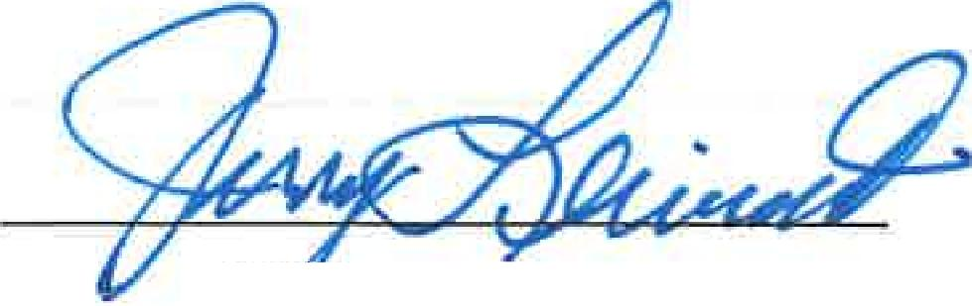
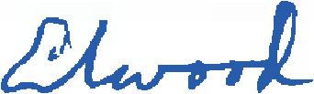
Je Leinart Charlie .tterson
President Vice President
3

