Caddo Basin Special Utility District

156 County Road 1118 Greenville, TX 75401-7514
www.caddobasincom (903) 527-3504
Caddo Basin Special Utility District
Notice of Regular Meeting of Board of Directors
February 25, 2025, at 6:30PM.
Meeting to be held at the District Office — 156 CR 1118, Greenville, TX 75401

FILED FOR RECORD
at I o'clock _{l} M
FEB 24 2025
AGENDA
BECKY LANDRUM


- Call To Order.
- Invocation.
- Public Comment:

The CBSUD Board will hear public comments for items not listed on the agenda, but any discussion shall be limited to the item being placed on the future agenda for further consideration or, if appropriate, direct the speaker to District staff for more information. Limit individual comments to three minutes with a maximum of fifteen minutes total for public comments.
- Approval of the Minutes:
Discuss and take appropriate action to approve the Minutes of the January 28, 2025, Board Meeting.
- Approval of the Financial Statement:
Discuss and take appropriate action to approve the Monthly Financial Statement for January 2025.
- Consider and act on Certification of Unopposed Candidates and Order of Cancellation for the May 3, 2025, election of directors.

(Considerar y actuar sobre⁻ la Certificacion de Candidatos sin Oposicion y la Orden de Cancelacion para la eleccion de directores del 3 de mayo de 2025.)
- Discuss construction for the new elevated tower, underground storage tank, and pump station:
Discuss and take appropriate action regarding construction of the new elevated tower, underground storage tank, and pump station.
- Discuss changing/cancelling future meeting dates due to conflicts and/or holidays.
Discuss and take appropriate action regarding changing/cancelling future meeting dates:
March 25th — Kevin & Jerry in Austin at TRWA Convention
May 27th — day after Memorial Day
November 25th — Thanksgiving week
December 23rd — Christmas week \
- Operation Managers Report:
- Executive Session:
At any time during the meeting and in compliance with the Texas Open Meetings Act, Chapter 551, Texas Government Code, the Board of Directors may meet in executive session on any of the above agenda items or other lawful items for consultation concerning attorney-client matters (§ 551.071); deliberation regarding real property (§ 551.072); deliberation regarding prospective gift (§ 551.073); personnel matters (§ 551.074); and deliberation regarding security devices (§ 551.076). Any subject discussed in executive session may be subject to action during the open portion of the meeting. The agenda items listed above may be addressed in the order presented or in any other order as deemed necessary by the Board of Directors.
- Discuss and take appropriate action regarding matters discussed in Executive Session.
12. Other matters presented by the Board Members, the public, or the staff.
2

- Future Agenda Items.
- Adjourn.

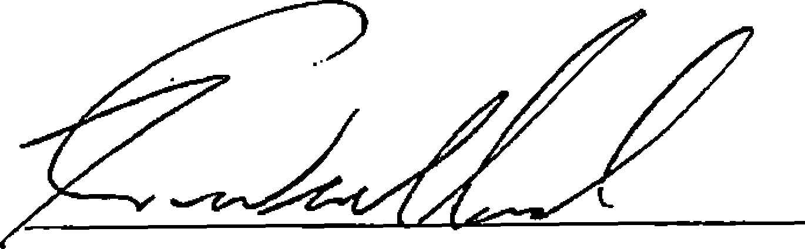
Kevin Wendland, General Manager
3

