BOARD OF DIRECTORS
MINUTES OF MEETING: February 25, 2025
The Board of Directors of Caddo Basin Special Utility District met in regular session on Tuesday, February 25, 2025, at the District Office, located in Floyd, Texas, at 6:30 p.m.
Present were.
Jerry Leinart, President
Charlie Patterson, Vice President Bear Boyle, Director
Ronnie Clack, Director
Kevin Wendland, General Manager Michelle Metcalf, Business Manager
Absent were:
Elwood Jones, Secretary/Treasurer Ken Pendergrass, Director
Kirk Hammack, Director
The meeting was called to order at 6:35 p.m.
- Invocation was given by: Kevin Wendland
- Public Comment: N/A
On a motion by Ronnie Clack, second by Bear Boyle, the Board unanimously approved the minutes for the January 28, 2025, meeting.

- On a motion by Charlie Patterson, second by Ronnie Clack, the Board unanimously approved the Financials for January 2025.
- On a motion by Ronnie Clack, second by Bear Boyle, the Board unanimously approved the Certification of Unopposed Candidates and Order of Cancellation for the May 3, 2025 Election of Directors.
- On the discussion of construction for the new elevated tower, underground storage tank, and pump station, no motion or action taken, the subject is tabled until the next meeting with an update on awarding the bids.
- Discuss changing/cancelling future meeting dates due to conflicts and/or holidays: no motion or action taken.
- Operation Managers Report: Discussion of system repairs, maintenance, and/or customer service matters.
- Executive Session:
At any time during the meeting and in compliance with the Texas Open Meetings Act, Chapter 551, Texas Government Code, the Board of Directors may meet in executive session on any of the above agenda items or other lawful items for consultation concerning attorney-client matters (§ 551.071); deliberation regarding real property (§ 551.072); deliberation regarding prospective gift (§ 551.073); personnel matters (§ 551.074); and deliberation regarding security devices (§ 551.076). Any subject discussed in executive session may be subject to action during the open portion of the meeting. The agenda items listed above may be addressed in the order presented or in any other order as deemed necessary by the Board of Directors.
N/A
- Discuss and take appropriate action regarding matters discussed in Executive Session: N/A
- Other matters presented by the Board Members, public, or the staff: N/A
- Future Agenda Items: N/A

12. On a motion by Ronnie Clack, second by Bear Boyle, and carried unanimously, the meeting was adjourned at 7:18 pm.

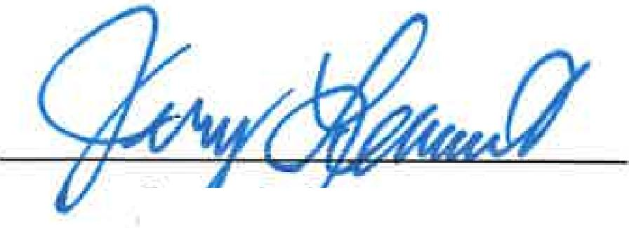
Je Le' art Elwood JiMes
President Secretary/Treasurer

