Caddo Basin Special Utility District

REC
156 County Road 1118 Greenville, TX 75401-7a14 FILED _{o'} ^{O} _{cloRORD} A ck rr M
www.caddobasin.com (903) 527-3504
JAN Z 7 2025
BECKY LANDRUM
County Clerk, Hunt County, Tex.

Caddo Basin Special Utility District by
Notice of Regular Meeting of Board of Directors
January 28, 2025, at 6:30PM.
Meeting to be held at the District Office —156 CR 1118, Greenville, TX 75401

AGENDA
- Call To Order.
- INocation.
- Public Comment:
The CBSUD Board will hear public comments for items not listed on the agenda, but any discussion shall be limited to the item being placed on the future agenda for further consideration or, if appropriate, direct the speaker to District staff for more information. Limit individual comments to three minutes with a maximum of fifteen minutes total for public comments.
- Approval of the Minutes:
Discuss and take appropriate action to approve the Minutes of the December 17, 2024, Board Meeting.
- Approval of the Financial Statement:
Discuss and take appropriate action to approve the Monthly Financial Statement for December 2024.

- Discuss, consider, and adopt Resolution Calling May 3, 2025, General Election of Directors - Order of Election. (Discutir, considerar y adoptar la Resolucion que convoca a las elecciones generates del 3 de mayo de 2025 de Directores - Orden de Eleccion.)
- Fourth Quarter Investment Report & Pledge Security Listing:
Discuss and take appropriate action to approve the Fourth Quarter Investment Report & Pledge Security Listing.
- Operation Managers Report:
- Executive Session:
At any time during the meeting and in compliance with the Texas Open Meetings Act, Chapter 551; Texas Government Code, the Board of Directors May meet in executive.session on any of the above agenda items or other lawful items for consultation concerning attorney-client matters (§ 551.071); deliberation regarding real property (§ 551.072); deliberation regarding .prospective gift (§.551.073); personnel matters (§ 551.074); and deliberation regarding security devices (§ 551.076). Any subject discussed in executive session may be subjeato action during the open portion of the meeting. The agenda itemilisted above may be addressed in the order presented or in any other order as deemed necessary by the Board of Directors.
- Discuss and take appropriate action regarding matters discussed in Executive Session.
- Other matters presented by the Board Members, the public, or the staff.

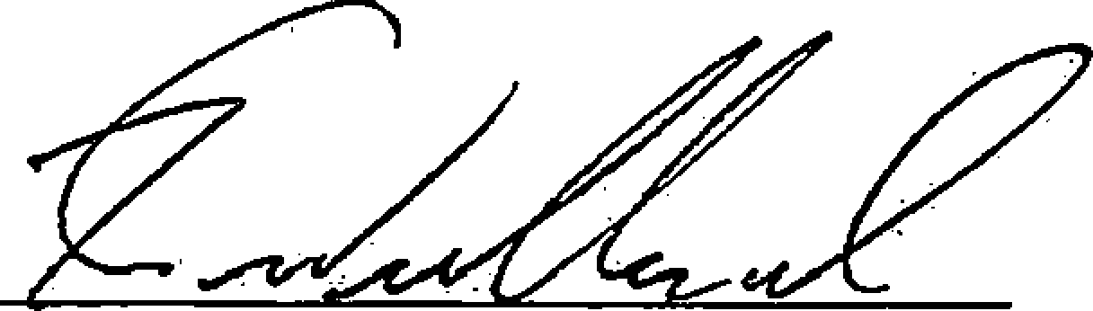
Kevin Wendland, General Manager
2
- Future Agenda Items.
- Adjourn.

.,
I


Hunt County Clerk
Becky Landrum, County Clerk
2507 Lee Street
2nd Floor
Greenville, TX 75401
(903) 408-4130
I i
1
Receipt: 26-1304
Product Name Extended
PUBNOT PUBLIC NOTICE $2.00
No Charge false
Public Notice $2.00
Total $2.00
Tender (On Account) $2.00
Account # CAD❑OBAS
i Account CADDO BASIN SPECIAL Name UTILITY DISTRICT
Balance ($192.00)
1
Thank You for Your Business 112712510:31 AM gloriah

