BOARD OF DIRECTORS
MINUTES OF MEETING: July 29, 2025
1
The Board of Directors of Caddo Basin Special Utility District met in regular session
on Tuesday, July 29, 2025, at the District Office located in Floyd, Texas at 6:30 p.m.
Present were:
Jerry Leinart, President
Charlie Patterson, Vice President Elwood Jones, Secretary/Treasurer Kirk Hammack, Director
Kenneth Pendergrass, Director Ronnie Clack, Director
Kevin Wendland, General Manager
Michelle Metcalf, Business Manager/ Deputy Secretary
Guests: Ronna Hodges, Attorney for Juan, Mary, & Eric DeLeon
Absent were: Bear Boyle, Director
The meeting was called to order at 6:26 p.m.
- Invocation was given by: Jerry Leinart
- Public Comment: N/A

- Request for review and clarification regarding a Non-Standard Service, Property ID 22892 and Property ID 22895, for Juan & Mary DeLeon, requested in writing from Ronna Hodges, Attorney at Law. The Board heard a statement from the customer's attorney expressing concerns about the estimate provided for the water line installation, specifically noting that the cost was perceived as too high. The General Manager will schedule an on-site meeting with the customer to review the project details and explain the estimate thoroughly once again.
2
- On a motion by Kirk Hammack, seconded by Ronnie Clack, the Board unanimously approved the Minutes from the June 24, 2025 Board Meeting.
- On a motion by Elwood Jones, seconded by Kenneth Pendergrass, the Board unanimously approved the Monthly Financial Statement for June 2025.
- On a motion by Ronnie Clack, seconded by Elwood Jones, the Board unanimously approved the Quarterly Investment Report and Pledge Report.
- Operation Manager's Report: Discussion of system repairs, maintenance, and/or customer service matters.
- Executive Session:
At any time during the meeting and in compliance with the Texas Open Meetings Act, Chapter 551, Texas Government Code, the Board of Directors may meet In executive session on any of the above agenda items or other lawful items for consultation concerning attorney-client matters (§ 551.071); deliberation regarding real property (§ 551.072); deliberation regarding prospective gift (§ 551.073); personnel matters (§ 551.074); and deliberation regarding security devices (§ 551.076). Any subject discussed in executive session may be subject to action during the open portion of the meeting. The agenda items listed above may be addressed in the order presented or in any other order as deemed necessary by the Board of Directors.
N/A
- Discuss and take appropriate action regarding matters discussed in Executive Session: N/A

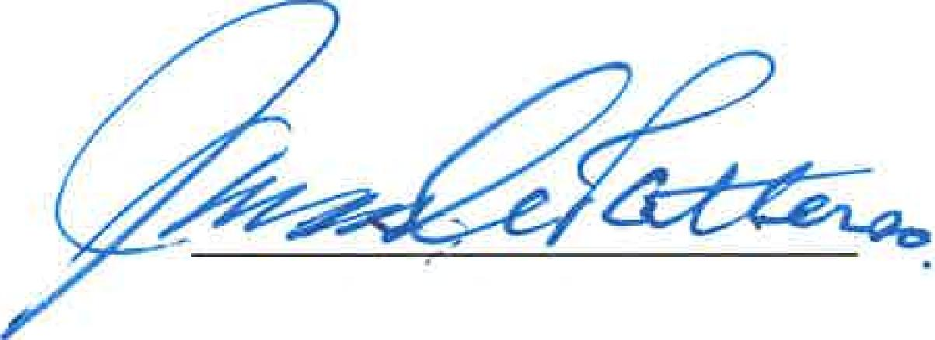
- Other matters presented by the Board Members, public, or the staff: N/A

Vice President or Secretary
- Future Agenda Items: Rate increase
- On a motion by Ronnie Clack, seconded by Elwood Jones, and carried unanimously, the meeting was adjourned at 7:33 p.m.

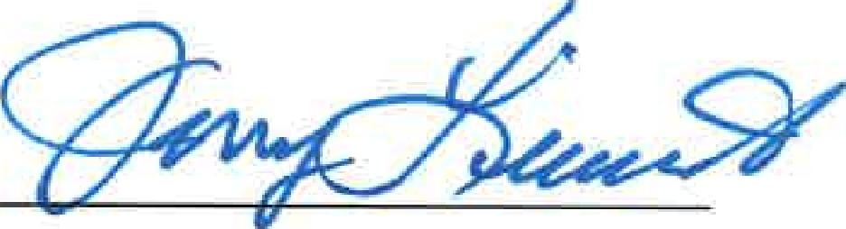
Jerry Leinart President
3

