1
 | Caddo Basin Special Utility District  156 County Road 1118 Greenville, TX 75401-7514  www.caddobasin.com (903) 52T3504

Caddo Basin Special Utility District
Notice of Regular Meeting of Board of Directors
June 24, 2025, at 6:30PM.
Meeting to be held at the District Office — 156 CR 1118, Greenville, TX 75401
AGENDA | FILED FOR RECORD  Vt r . "7 c.-/ o'clock .4 M

JUN 2 4 2025
Call To Order.
BECKY LANDRUM
County Clerk, litnit County, Tex. by
Invocation.
Public Comment:

The CBSUD Board will hear public comments for items not listed on the agenda, but any discussion shall be limited to the item being placed on the future agenda for further consideration or, if appropriate, direct the speaker to District staff for more information. Limit individual comments to three minutes with a maximum of fifteen minutes total for public comments.
- Approval of the Minutes:
Discuss and take appropriate action to approve the Minutes of the May 27, 2025, Board Meeting.
- Approval of the Financial Statement:
Discuss and take appropriate action to approve the Monthly Financial Statement for May 2025.

- Operation Managers Report; Discussion of system repairs, maintenance, and/or customer service matters.
- Executive Session:

At any time during the meeting and in compliance with the Texas Open Meetings Act, Chapter 551, Texas Government Code, the Board of Directors may meet in executive session on any of the above agenda items or other lawful items for consultation concerning attorney-client matters (§ 551.071); deliberation regarding real property (§ 551.072); deliberation regarding prospective gift (§ 551.073); personnel matters (§ 551.074); and deliberation regarding security devices (§ 551.076). Any subject discussed in executive session may be subject to action during the open portion of the meeting. The agenda items listed above may be addressed in the order presented or in any other order as deemed necessary by the Board of Directors.


- Discuss and take appropriate action regarding matters discussed in Executive Session.
2
..)
- Other matters presented by the Board Members, the public, or the staff.
- Future Agenda Items.
- Adjourn.
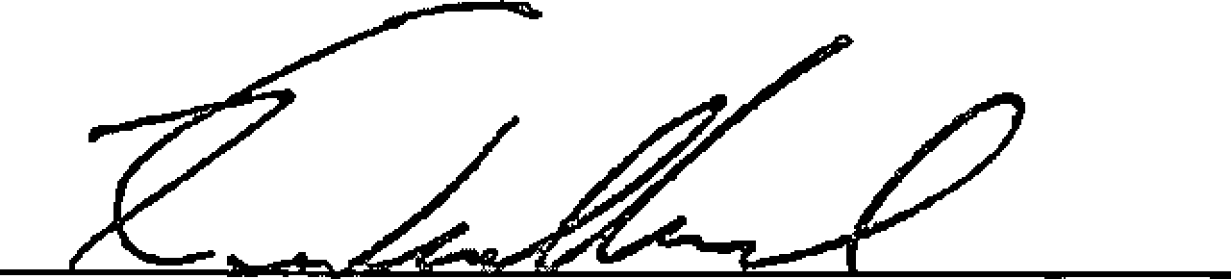
Kevin Wendland, General Manager


Hunt County Clerk
Becky Landrum, County Clerk
2507 Lee Street
2nd Floor
Greenville, TX 75401
(903) 408-4130
Receipt: 25-10813
Product Name Extended
PUBNOT PUBLIC NOTICE $2.00
NoCharge false
Public Notice $2.00
Total $2.00
Tender (On Account) $2.00
Account # CADDOBAS
Account CADDO BASIN SPECIAL
Name UTILITY DISTRICT
Balance ($1$4.00)
Thank You for Your Business 6124125 9:42 AM glorlah

