BOARD OF DIRECTORS
MINUTES OF MEETING: June 24, 2025
1
The Board of Directors of Caddo Basin Special Utility District met in regular session
on Tuesday, June 24, 2025, at the District Office located in Floyd, Texas at 6:30 p.m.
Present were:
Jerry Leinart, President
Charlie Patterson, Vice President
Elwood Jones, Secretary/Treasurer
Bear Boyle, Director
Kirk Hammack, Director
Kenneth Pendergrass, Director
Ronnie Clack, Director
Kevin Wendland, General Manager
Michelle Metcalf, Business Manager/ Deputy Secretary
Absent were: NONE
The meeting was called to order at 6:30 p.m.
- Invocation was given by: Kirk Hammack
- Public Comment: N/A
- On a motion by Kenneth Pendergrass, seconded by Ronnie Clack, the Board unanimously approved the Minutes from the May 27, 2025, Board Meeting.
- On a motion by Ronnie Clack, seconded by Kenneth Pendergrass, the Board unanimously approved the Financial Statement for May 2025.

- Operation Manager's Report: Discussion of system repairs, maintenance, and/or customer service matters.

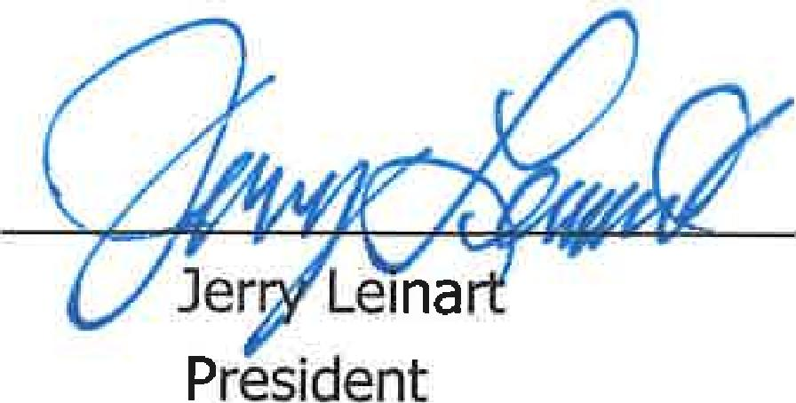
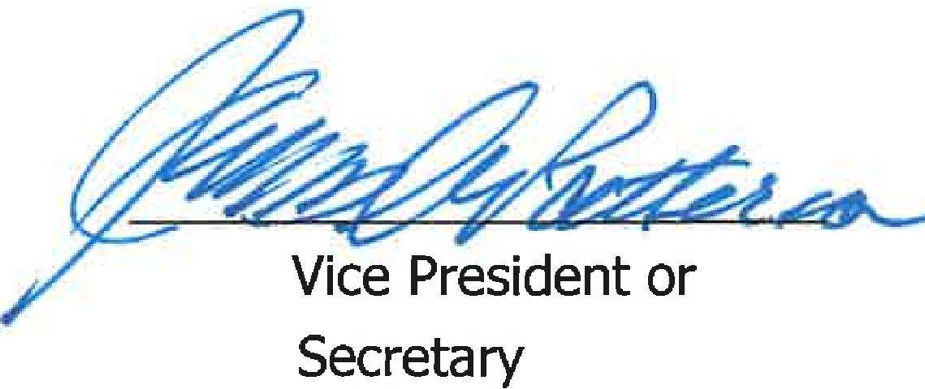
Vice President or Secretary
2
- Executive Session:
At any time during the meeting and in compliance with the Texas Open Meetings Act, Chapter 551, Texas Government Code, the Board of Directors may meet in executive session on any of the above agenda items or other lawful items for consultation concerning attorney-client matters (§ 551.071); deliberation regarding real property (§ 551.072); deliberation regarding prospective gift (§ 551.073); personnel matters (§ 551.074); and deliberation regarding security devices (§ 551.076). Any subject discussed in executive session may be subject to action during the open portion of the meeting. The agenda items listed above may be addressed in the order presented or in any other order as deemed necessary by the Board of Directors.
N/A
- Discuss and take appropriate action regarding matters discussed in Executive Session' N/A
- Other matters presented by the Board Members, public, or the staff: N/A
- Future Agenda Items: N/A
- On a motion by Kirk Hammack, seconded by Elwood Jones, and carried unanimously, the meeting was adjourned at 6:57 p.m.

