1 of 2-

Caddo Basin Special Utility District
156 County Road 1118 Greenville, TX 75401-7514
wvvw.caddobasinicorn (903) 527-3504
Caddo Basin Special Utility District
Notice of Regular Meeting of Board of Directors
March 31, 2026, at 6:30PM.
Meeting to be held at the District Office — 156 CR 1118, Greenville, TX 75401
AGENDA
FILED
- Call To Order.
- Invocation.
- Public Comment:
3/25/2026 9:36:28 AM
STACEY KEMP
COUNTY CLERK
COLLIN COUNTY. TEXAS
BY KM DEPUTY
The CBSUD Board will hear public comments for items not listed on the agenda,
but any discussion shall be limited to the item being placed on the future
agenda for further consideration or, if appropriate, direct the speaker to District
staff for more information. Limit individual comments to three minutes with a
maximum of fifteen minutes total for public comments.
4. Approval of the Minutes: 111
Discuss and take appropriate action to approve the Minutes from February 24,
2026, Board Meeting.
5. Approval of the Financial Statements:
Discuss and take appropriate action to approve the Monthly Financial
Statements for February 2026.
S
- 2 of 2 -
- Operation Manager's Report.
Discussion of system repairs, maintenance, and/or customer service matters.
- Executive Session:
At any time during the meeting and in compliance with the Texas Open
Meetings Act, Chapter 551, Texas Government Code, the Board of Directors
may meet in executive session on any of the above agenda items or other
lawful items for consultation concerning attorney-client matters (§ 551.071);
deliberation regarding real property (§ 551.072); deliberation regarding
prospective gift (§ 551.073); personnel matters (§ 551.074); and deliberation
regarding security devices (§ 551.076). Any subject discussed in executive
session may be subject to action during the open portion of the meeting. The
agenda items listed above may be addressed in the order presented or in any
other order as deemed necessary by the Board of Directors.
- Discuss and take appropriate action regarding matters discussed in Executive Session.
- Other matters presented by the Board Members, the public, or the staff.
- Future Agenda Items.
- Adjourn.
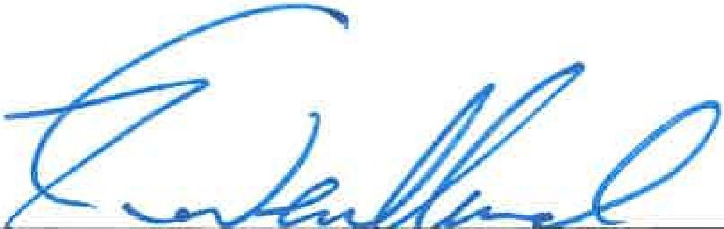
Kevin Wendland, General Manager
2

