BOARD OF DIRECTORS
MINUTES OF MEETING: May 27, 2025
1
The Board of Directors of Caddo Basin Special Utility District met in regular session on Tuesday May 27, 2025, at the District Office located in Floyd, Texas at 6:30 p.m.
Present were:
Jerry Leinart, President
Elwood Jones, Secretary/Treasurer
Bear Boyle, Director
Kenneth Pendergrass, Director
Ronnie Clack, Director
Kevin Wendland, General Manager
Michelle Metcalf, Business Manager
Guest: Robert Lake from Rutherford Taylor & Company PC
Absent were:
Charlie Patterson, Vice President Kirk Hammack, Director
The meeting was called to order at 6:32 p.m,
- Invocation was given by: Elwood Jones
- Public Comment: N/A
- On a motion by Ronnie Clack, seconded by Elwood Jones, the Board unanimously accepted the 2024 Audit, presented by Robert Lake. The report was unmodified.

- On a motion by Bear Boyle, seconded by Elwood Jones, the Board unanimously approved the minutes for the April 22, 2025, Board Meeting.
2
- On a motion by Kenneth Pendergrass, seconded by Ronnie Clack, the Board unanimously approved the Financial Statement for April 2025.
- On a motion by Elwood Jones, seconded by Bear Boyle, the Board unanimously approved the updated Personnel Policy.
- Administer the Oath of Office & execute the Oath of Office Forms for unopposed. No action taken or needed.
- Elect Board Officers, reorganization of the Board: On a motion by Ronnie Clack, second by Kenneth Pendergrass, the Board unanimously agreed to keep the Board Officers the same as the present; Jerry Leinart-President, Charlie Patterson-Vice President and Elwood Jones-Secretary/Treasurer. Also, on a motion by Elwood Jones, seconded by Ronnie Clack, and carried unanimously, the Board appointed Michelle Metcalf, the Business Manager, as the Deputy Secretary for the District.
- On a motion by Kenneth Pendergrass, seconded by Elwood Jones, and carried unanimously, the Board told the General Manager to go forward with the Field Hawk program for paperless work orders.
- Operation Managers Report: Discussion of system repairs, maintenance, and/or customer service matters.
- Executive Session:
At any time during the meeting and in compliance with the Texas Open Meetings Act, Chapter 551, Texas Government Code, the Board of Directors may meet in executive session on any of the above agenda items or other lawful items for consultation concerning attorney-client matters (§ 551.071); deliberation regarding real property (§ 551.072); deliberation regarding prospective gift (§ 551.073); personnel matters (§ 551.074); and deliberation regarding security devices (§ 551.076). Any subject discussed in executive session may be subject to action during the open portion of the meeting. The agenda items listed above may be addressed in the order presented or in any other order as deemed necessary by the Board of Directors.

n N/A
- Discuss and take appropriate action regarding matters discussed in Executive Session: N/A
- Other matters presented by the Board Members, public, or the staff: N/A
- Future Agenda Items: N/A
- On a motion by Ronnie Clack, seconded by Elwood Jones, and carried unanimously, the meeting was adjourned at 7:41 pm.

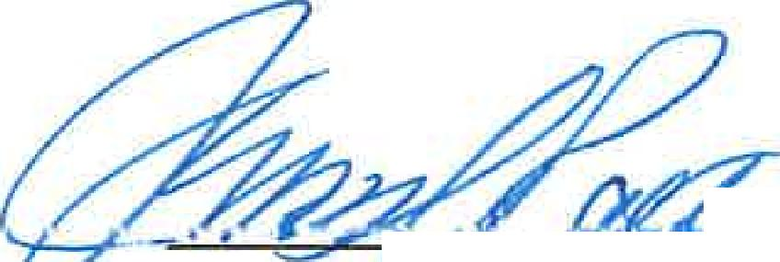
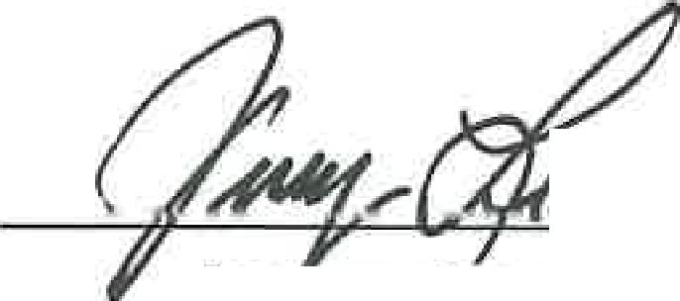
.--- r 24-7,5-

)
e,e,f Asp,Q,
Jer Leinart
President
3
Vice President or Secretary

