Caddo Basin Special Utility District

1
156 County Road 1118 Greenville, TX 75401-7514
www.caddobasin.com (903) 527-3504
Caddo Basin Special Utility District
Notice of Regular Meeting of Board of Directors
October 28, 2025, at 6:30PM.
Meeting to be held at the District Office — 156 CR 1118, Greenville, TX 75401
AGENDA
ILEDk9w R RECOR at (11clock
- Cali To Order.  - Invocation.  - Public Comment: | OCT 1 7 2025  BECKY LANDRUM  County Clerk, Hurt County, TeX. by

The CBSUD Board will hear public comments for items not listed on the agenda,
but any discussion shall be limited to the item being placed on the future agenda for further consideration or, if appropriate, direct the speaker to District staff for more information. Limit individual comments to three minutes with a maximum of fifteen minutes total for public comments.
- Approval of the Minutes:
Discuss and take appropriate action to approve the Minutes of the September 23, 2025, Board Meeting.
- Approval of the Financial Statement:
Discuss and take appropriate action to approve the Monthly Financial Statement for September 2025.

- Approval of the Third Quarter investment Report & Pledge Security Listing:
Discuss and take appropriate action to approve the Third Quarter Investment Report & Pledge Security Listing.
- Consider amending the 2025 Budget:
Discuss and take appropriate action to approve amending the 2025 Budget.
- Consider the proposed Budget for 2026.
''Discuss' and take appropriate action to approve the proposed Budget for 2026.
- Operation Manager's Report.
" Discussion of system repairs, maintenance, and/or customer service matters.
- Executive Session:
At any time during the meeting and in compliance with the Texas Open Meetings Act, Chapter 551, Texas Government Code, the Board of Directors may meet in executive session on any of the above agenda items or other lawful items for consultation concerning attorney-client matters (§ 551.071); deliberation regarding real property (§ 551.072); deliberation regarding prospective gift (g 551.073); personnel matters (§ 551.074); and deliberdllan regarding security devices (§ 551.076). Any subject discussed in executive session may be subject to action during the open portion of the meeting. The agenda items listed above may be addressed in the order presented or in any other order as deemed necessary by the Board of Directors.
- Discuss and take appropriate action regarding matters discussed in Executive Session.

12. Other matters presented by the Board Members, the public, or the staff.
2

- Future Agenda Items.
- Adjourn.

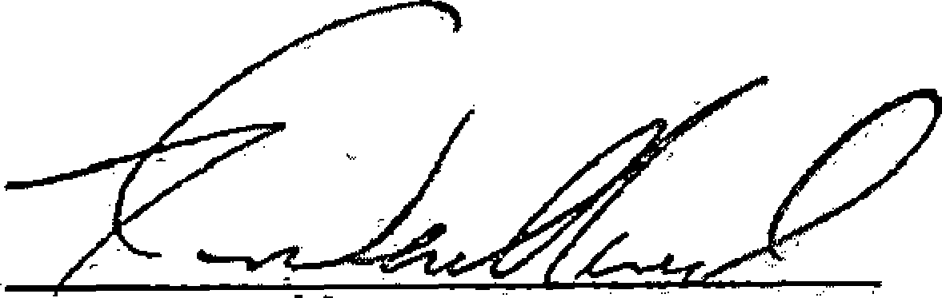
Kevin Wendland, General Manager
3

