BOARD OF DIRECTORS
1
MINUTES OF MEETING: October 28, 2025
The Board of Directors of Caddo Basin Special Utility District met in regular session on Tuesday, October 28, 2025, at the District Office located in Floyd, Texas at 6:30 p.m.
Present were:
Jerry Leinart, President
Elwood Jones, Secretary/Treasurer
Kirk Hammack, Director
Bear Boyle, Director
Kenneth Pendergrass, Director
Ronnie Clack, Director
Kevin Wendland, General Manager
Michelle Metcalf, Business Manager/ Deputy Secretary
Absent were:
Charlie Patterson, Vice President
- The meeting was called to order at 6:33 p.m.
- Invocation was given by: Kevin Wendland
- Public Comment: N/A

- On a motion by Ronnie Clack, seconded by Kenneth Pendergrass, the Board unanimously approved the Minutes from the September 23, 2025, Board Meeting.
2
- On a motion by Kenneth Pendergrass, seconded by Elwood Jones, the Board unanimously approved the Monthly Financial Statement for September 2025.
- On a motion by Elwood Jones, seconded by Ronnie Clack, the Board unanimously approved the Third Quarter Investment Report and Pledge Security Listing.
- On a motion by Kenneth Pendergrass, seconded by Elwood Jones, the Board unanimously approved the amendments on the 2025 Budget.
- On a motion by Elwood Jones, seconded by Kirk Hammack, the Board unanimously approved the proposed Budget for 2026.
- Operation Manager's Report: Discussion of system repairs, maintenance, and/or customer service matters.
- Executive Session:
At any time during the meeting and in compliance with the Texas Open Meetings Act, Chapter 551, Texas Government Code, the Board of Directors may meet in executive session on any of the above agenda items or other lawful items for consultation concerning attorney-client matters (§ 551.071); deliberation regarding real property (§ 551.072); deliberation regarding prospective gift (§ 551.073); personnel matters (§ 551.074); and deliberation regarding security devices (§ 551.076). Any subject discussed in executive session may be subject to action during the open portion of the meeting. The agenda items listed above may be addressed in the order presented or in any other order as deemed necessary by the Board of Directors.
- Discuss and take appropriate action regarding matters discussed in Executive Session: The Board went into Executive Session at 7:02 pm and reconvened at 7:17pm. On a motion by Kenneth Pendergrass, seconded by Kirk Hammack and

carried unanimously, The Board authorized the General Manager to give bonuses to all eligible employees in pre-determined amounts and approved a bonus and a raise for 2026 for the General Manager. The Board also approved extending the General Manager's contract for another year. The Board also approved in this session to continue paying for 75% of employee's dependents health insurance.
- Other matters presented by the Board Members, public, or the staff: Unanimously decided to skip the December 2025 Board Meeting due to the holidays.
- Future Agenda Items: N/A
- On a motion by Ronnie Clack, seconded by Kenneth Pendergrass, and carried unanimously, the meeting was adjourned at 7:24 p.m.

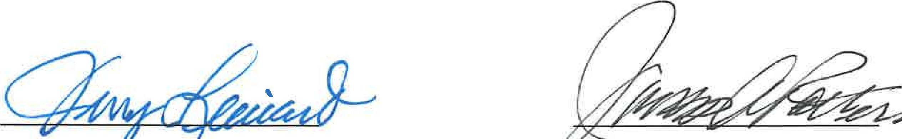

Jer I eina Vice President or
3
President Secretary

