Caddo Basin Special Utility District

1
156 County Road 1118 Greenville, TX 75401-7514
www.caddobasin.com (903) 527- 3504
Caddo Basin Special Utility District
Notice of Regular Meeting of Board of Directors
September 23, 2025, at 6:30PM.
Meeting to be held at the District Office — 156 CR 1118, Greenville, TX 75401
AGENDA
- Call To Order.  - Invocation.  - Public Comment: | _{at} _ _{Li} FILE FORRE_{k}CORD f_{i\A}  SEP 1 8 2025  BECKY LANDRUM  County Clerk, Hunt County, Tex.  by ₎igk_{Ittc},„

The CBSUD Board will hear public comments for items not listed on the agenda,
but any discussion shall be limited to the item being placed on the future agenda for further consideration or, if appropriate, direct the speaker to District staff for more information. Limit individual comments to three minutes with a maximum of fifteen minutes total for public comments.
- Approval of the Minutes:
Discuss and take appropriate action to approve the Minutes of the August 26, 2025, Board Meeting.
- Approval of the Financial Statement:
Discuss and take appropriate action to approve the Monthly Financial Statement for August 2025.
- Approval of the Rate Increase for 2026: Discuss and take appropriate action to approve the rate increase for 2026.

- Operation Manager's Report.
Discussion of system repairs, maintenance, and/or customer service matters.
- Executive Session:
At any time during the meeting and in compliance with the Texas Open Meetings Act, Chapter 551, Texas Government Code, the Board of Directors
may meet in executive session on any of the above agenda items or other lawful items for consultation concerning attorney-client matters (§ 551.071);
deliberation regarding real property (§ 551.072); deliberation regarding prospective gift (§ 551.073); personnel matters (§ 551.074); and deliberation
regarding security devices (§ 551.076). Any subject discussed in executive
'May be subject to action during the open portion of the meeting. The agenda items listed above may be addressed in the order presented or in any other order as deemed necessary by the Board of Directors.
- Discuss and take ippropriate action regarding matters discussed in Executive Session.


- Other matters presented by the Board Members, the publi
- Future Agenda items.
- Adjourn.

Hunt County Clerk
Becky Landrum, County Clerk
2507 Lee Street
2nd Floor
Greenville, TX 75401
(903) 408-4130

Receipt: 25-16229
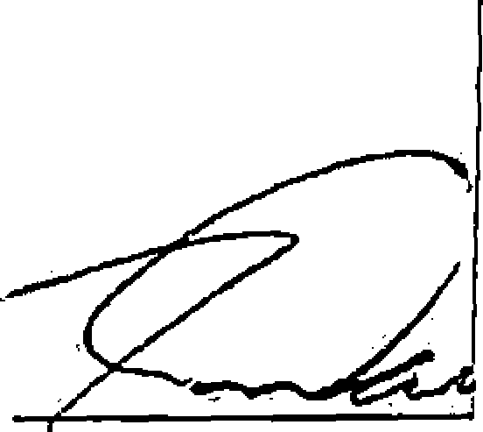
Kevin Wendland, G
Product Name
Extended
$2.00
false
$2.00
$2.00
$2.00
PUBNOT PUBLIC NOTICE
No Charge
Public Notice
Total
Tender (On Account)
Account # CADDOBAS
Account CADDO BASIN SPECIAL
Name UTILITY DISTRICT
Balance 0178.00)

Thank You for Your Business 9/16125 4:26 PM &Man

