BOARD OF DIRECTORS
1
MINUTES OF MEETING: September 23, 2025
The Board of Directors of Caddo Basin Special Utility District met in regular session on Tuesday, September 23, 2025, at the District Office located in Floyd, Texas at 6:30 p.m.
Present were:
Jerry Leinart, President
Elwood Jones, Secretary/Treasurer
Kirk Hammack, Director
Bear Boyle, Director
Kenneth Pendergrass, Director
Ronnie Clack, Director
Kevin Wendland, General Manager
Michelle Metcalf, Business Manager/ Deputy Secretary
Absent were:
Charlie Patterson, Vice President
The meeting was called to order at 6:32 p.m
1. Invocation was given by: Bear Boyle

- Public Comment: N/A
- On a motion by Kenneth Pendergrass, seconded by Elwood Jones, the Board unanimously approved the Minutes from the August 26, 2025 Board Meeting.
- On a motion by Elwood Jones, seconded by Ronnie Clack, the Board unanimously approved the Monthly Financial Statement for August 2025.
- On a motion by Kirk Hammack, seconded by Elwood Jones, and the Board unanimously approved the rate increase for 2026 as follows: Base fee $42.00; 0-5,000 gallon tier $6.26/1,000 gal; 5,001-15,000 gallon tier $10.12/1,000 gal; 15,000+ gallon tier $13.25/1,000 gal; Industrial base rate is based on meter size and has a flat rate of $11.00 per 1,000 gallons. Institutional and Churches base rate is based on meter size and will be charged the top two residential tiers. Irrigation meter rates are the same as residential rates.
- Operation Manager's Report: Discussion of system repairs, maintenance, and/or customer service matters.
- Executive Session:
At any time during the meeting and in compliance with the Texas Open Meetings Act, Chapter 551, Texas Government Code, the Board of Directors may meet in executive session on any of the above agenda items or other lawful items for consultation concerning attorney-client matters (§ 551.071); deliberation regarding real property (§ 551.072); deliberation regarding prospective gift (§ 551.073); personnel matters (§ 551.074); and deliberation regarding security devices (§ 551.076). Any subject discussed in executive session may be subject to action during the open portion of the meeting. The agenda items listed above may be addressed in the order presented or in any other order as deemed necessary by the Board of Directors.
N/A
- Discuss and take appropriate action regarding matters discussed in Executive Session: N/A
- Other matters presented by the Board Members, public, or the staff: N/A 2

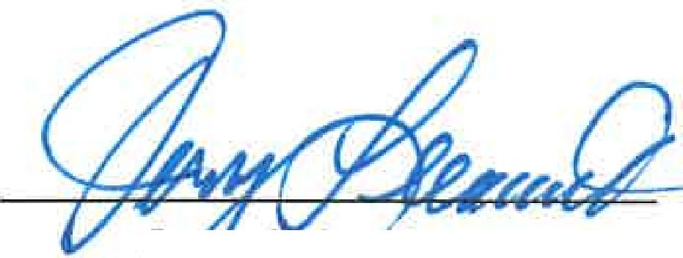
- Future Agenda Items: 2026 Budget
- On a motion by Kirk Hammack, seconded by Bear Boyle, and carried unanimously, the meeting was adjourned at 7:20 p.m.

741.4,. c u
3
J Leinart Vice President or
President Secretary

